**IST471**

**Classroom Assignment 4 (20 points)**

**GROUP 2**

**Manuel A. Bolanos-Tapia**

**Ethan Flores**

**Tyler Brown**

**Alexa Schnetzler**

Problem: List every book and compare its cost with the lowest cost.

Expected output:

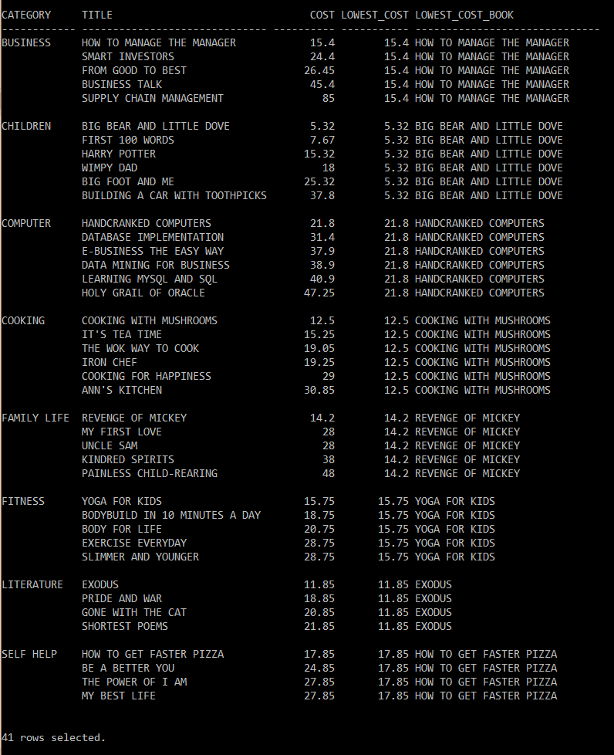

Break on category skip 1;

select category, title, cost,

MIN(cost)OVER(PARTITION BY category ORDER BY category

rows between unbounded preceding and unbounded following)LOWEST_COST,

MIN(title)OVER(PARTITION BY category ORDER BY category

rows between unbounded preceding and unbounded following)LOWEST_COST_BOOK

from books;

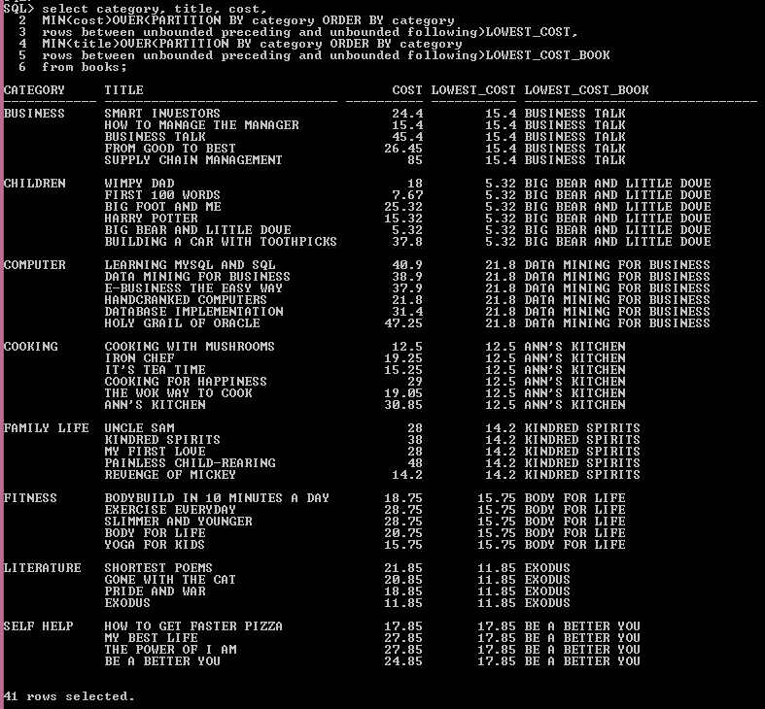

2. Find out the different between the pay of each employee and the lowest pay in the same department.

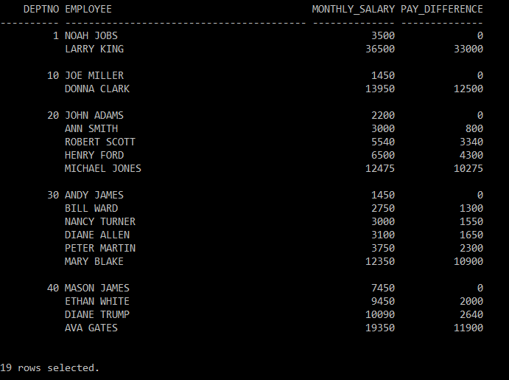

select deptno, firstname || ', ' || lastname employee, monthly_salary,

(monthly_salary -

(MIN(monthly_salary)over(partition by deptno order by monthly_salary rows between unbounded preceding and unbounded following)))pay_difference

from emp;

